OPEN STATEWIDE ---CM COMU's Incident Tactical Dispatcher (INTD) Training Course
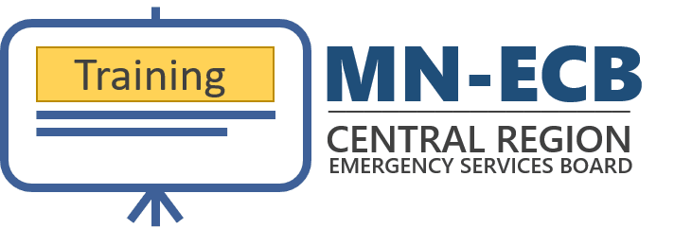
Central Minnesota's COMU's Incident Tactical Dispatcher (INTD) Training Course for January 26-29, 2026 is now open for statewide registration. Priority registration is given to the Central Minnesota Radio Region until December 5, 2025.

Update:
Opened for statewide registration on 11/17/2025.

Registration:
- Limited to 20 students!
- Priority registration is given to the Central Minnesota Radio Region until December 5, 2025.
- Register ASAP for a seat, and we'll contact the first 20 registrants in order to collect transcripts at a later time.
View it on website

